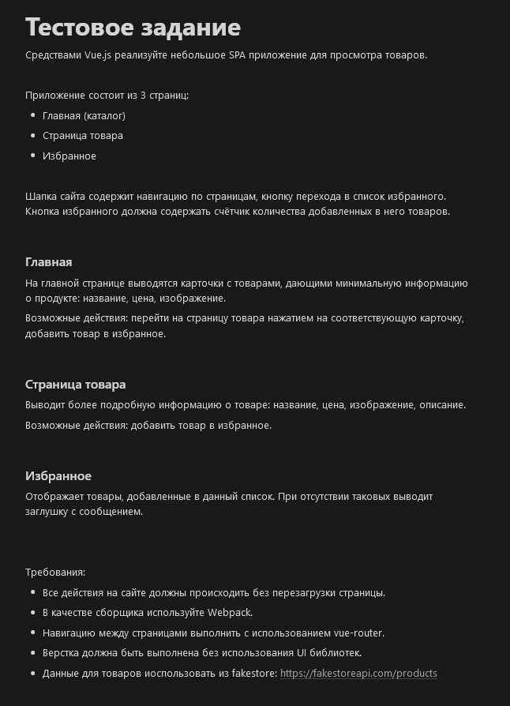

<https://third-brick-abd.notion.site/535079f965b649d59d689ba9b85d7735>

Данные

https://fakestoreapi.com/products

Макет

https://www.figma.com/design/RKOAMn1cbx7tfBnsvSAPsQ/%D0%A2%D0%B5%D1%81%D1%82%D0%BE%D0%B2%D0%BE%D0%B5-%D0%B7%D0%B0%D0%B4%D0%B0%D0%BD%D0%B8%D0%B5-(Copy)?node-id=0-1&t=T6pAoGeVb1jTs0xe-0